Part 2; DHCP server configuration and management
Installing the dhcp-server package use the command; sudo dnf install dhcp-server -y
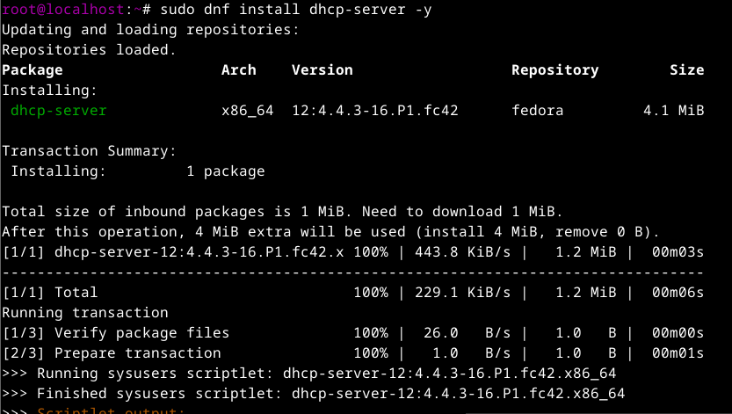
To confirm installation use the command; rpm -q dhcp-server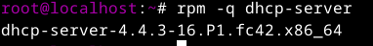
NOTE; The main configuration file for DHCP-Server is; /etc/dhcp/dhcpd.conf
To edit configuration file use the command; nano /etc/dhcp/dhcpd.conf
To view the content use the command ; cat /etc/dhcp/dhcpd.conf
Once configured, enable and start the DHCP service using the commands below:
- sudo systemctl enable dhcpd
- sudo systemctl start dhcpd
- sudo systemctl status dhcpd

Firewall Configuration-Allow DHCP traffic through the firewall to ensure proper communication with clients:
sudo firewall-cmd --add-service=dhcp --permanent
sudo firewall-cmd –reload
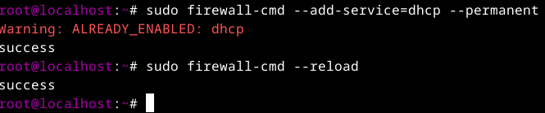

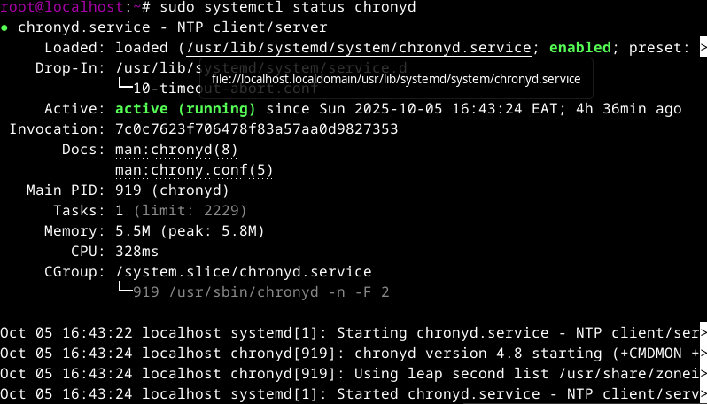
NOTE; The main configuration file is /etc/chrony.conf
To edit the configuration file use the command; nano /etc/chrony.conf
Start and Enable NTP use the command; sudo systemctl start chronyd and sudo systemctl enable chronyd
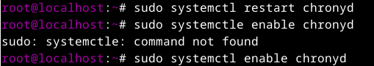
Firewall Configuration If you have the firewall enabled, allow NTP traffic through the command; sudo firewall-cmd --add-service=ntp --permanent and sudo firewall-cmd –reload
Verification Check the status of the NTP service to ensure it's running use the command; sudo systemctl status chronyd

